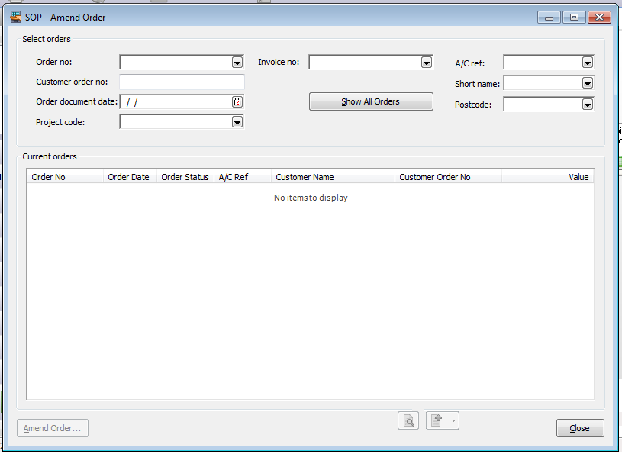
Above: Sage.MMS.SOP.AmendOrderForm
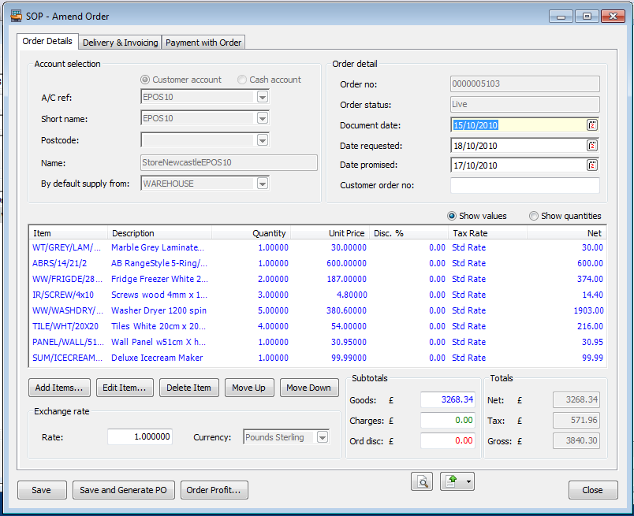
Above: Sage.MMS.SOP.AmendOrderDetailsForm

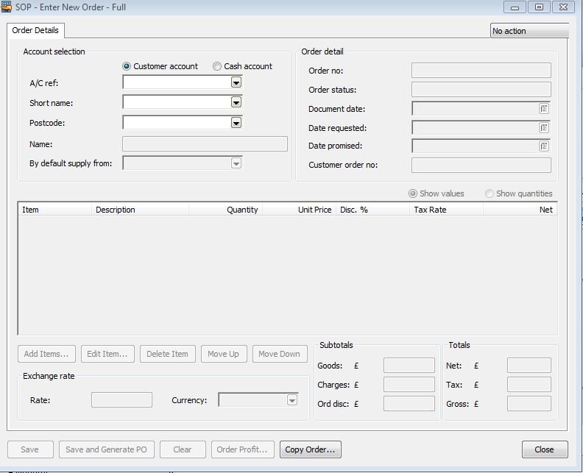
Above: Sage.MMS.SOP.EnterNewOrderFullForm

